**Century College**

**CSCI2005 – Fall16**

**Lab6**

**Due on 10/27**

(Text Book Project 1) For this lab you are asked to do Project 1 from chapter 5 on page 226.

**Note:** this time I am providing you both chapter05-project01.html and chapter05-project01.html to start with.

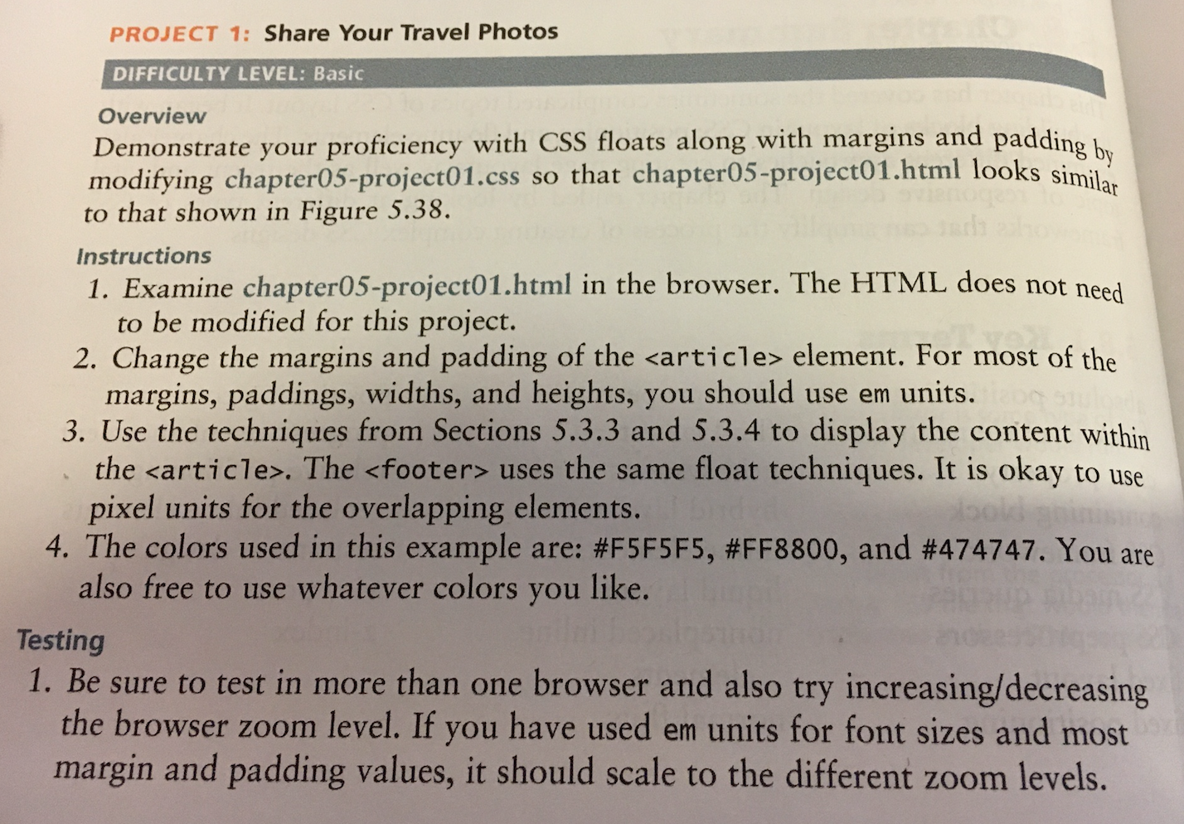

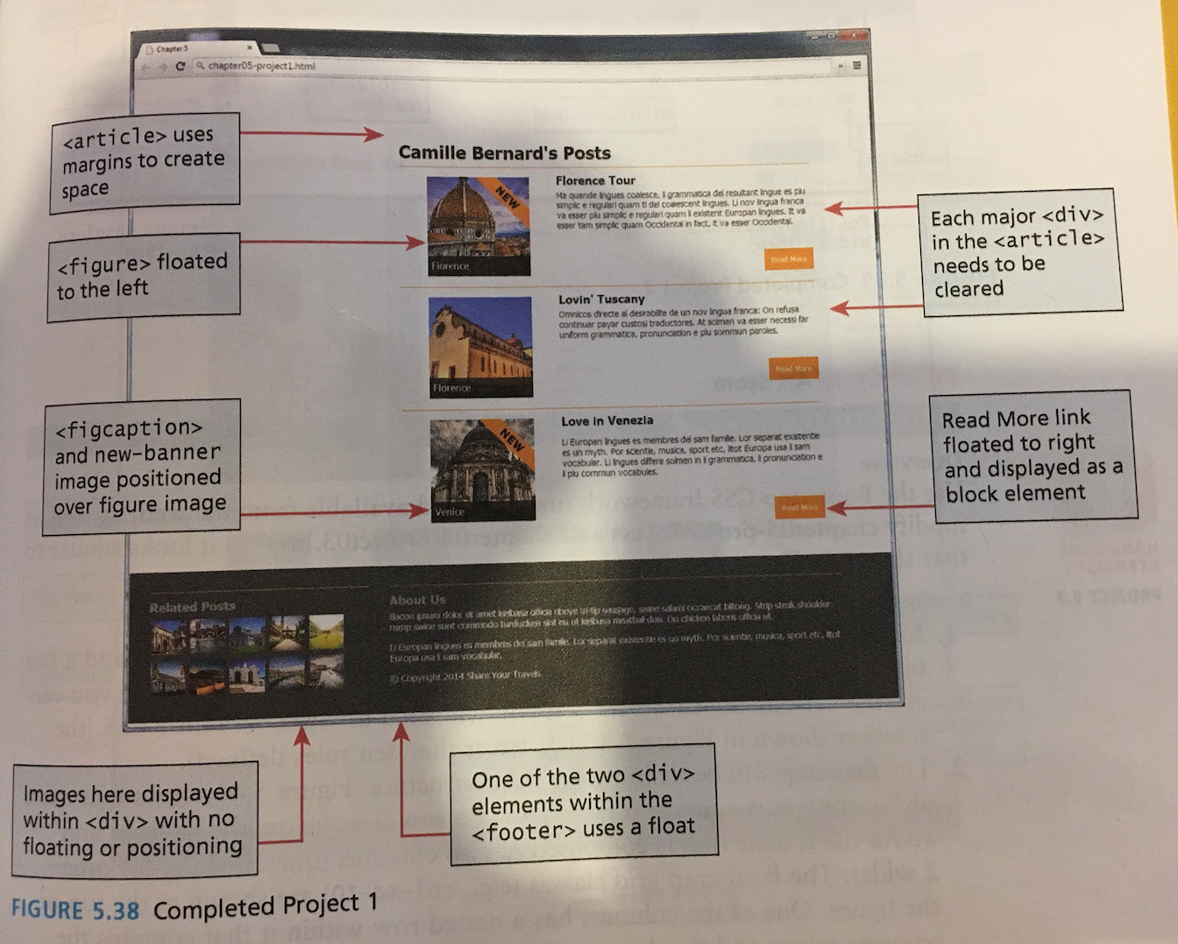

***Requirements:***

* You must submit valid and semantically appropriate HTML5.
* Your Successful validation as an HTML5 page by using the W3C validation site (<https://validator.w3.org/#validate_by_upload>). Capture the web page that reports successful validation and past it to a word document

***Submitting***

Put your assignment in a folder named lab6. Put all resources used by your assignment into this folder. Upload this folder to the submit drive (make sure zip it first). You will lose marks if you do not follow these submission instructions.